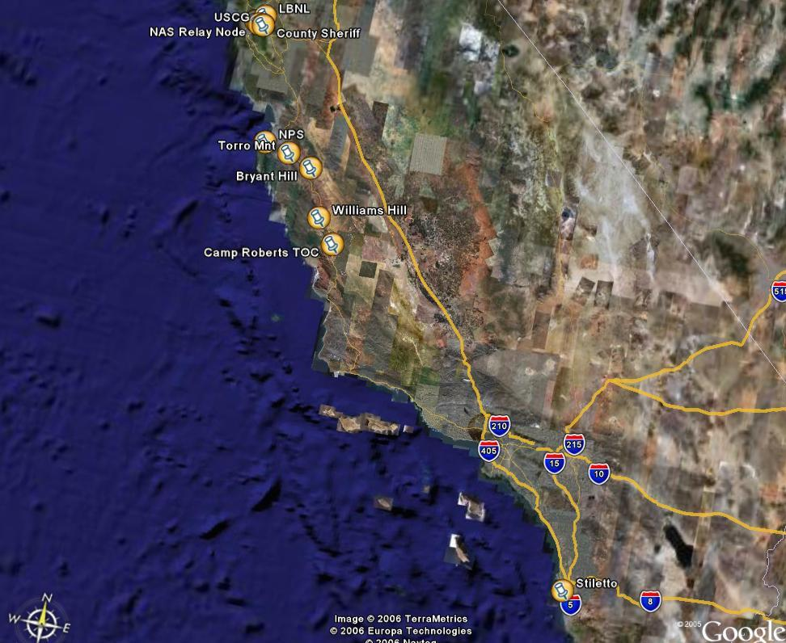
Overall MIO TNT06-4 sites view

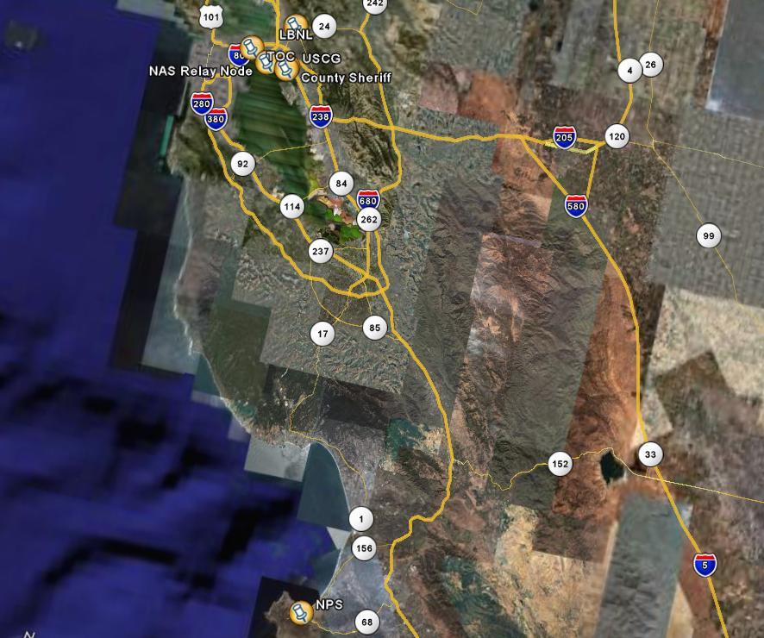
NPS NOC and SF Bay MIO 06-4 operation area

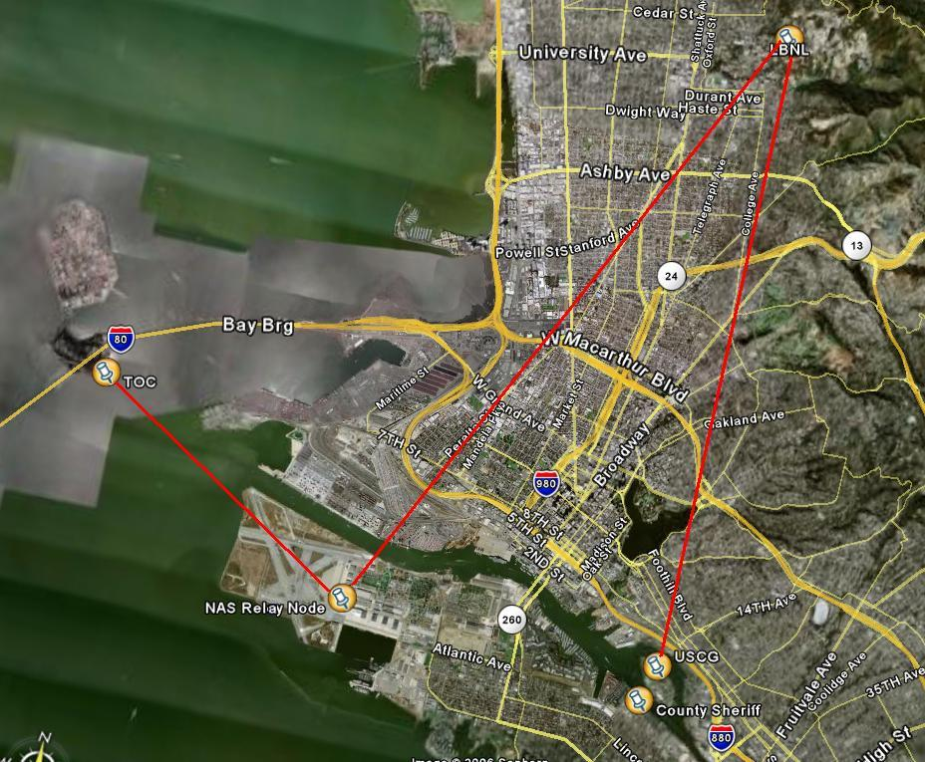
SF Bay OFDM links

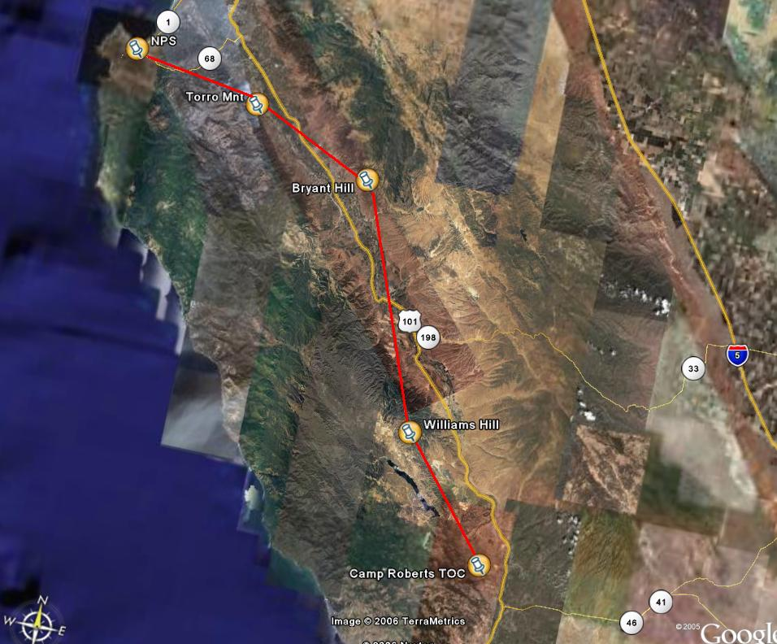
NPS – Camp Roberts OFDM backbone.
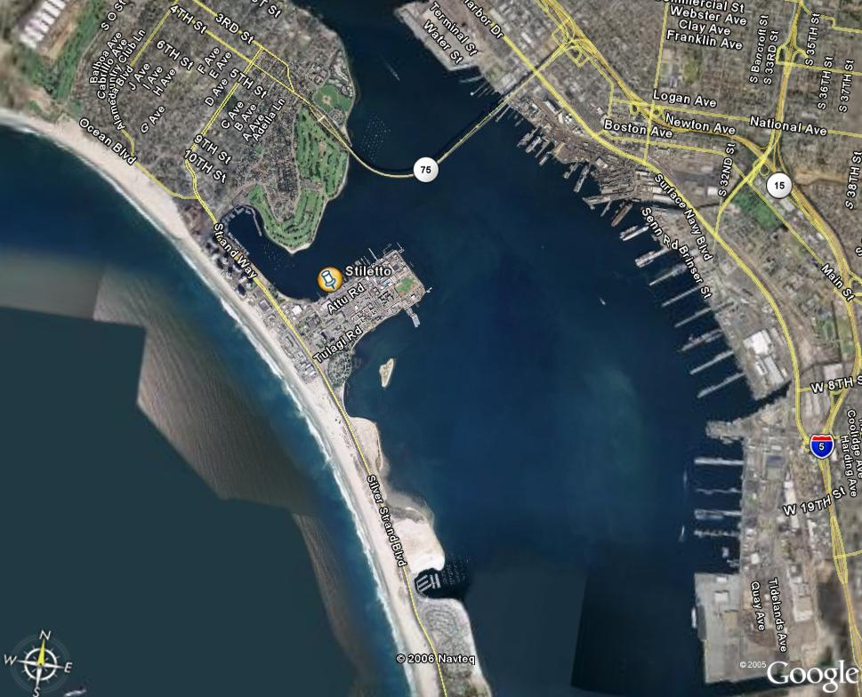
Stiletto location in San Diego Bay.

